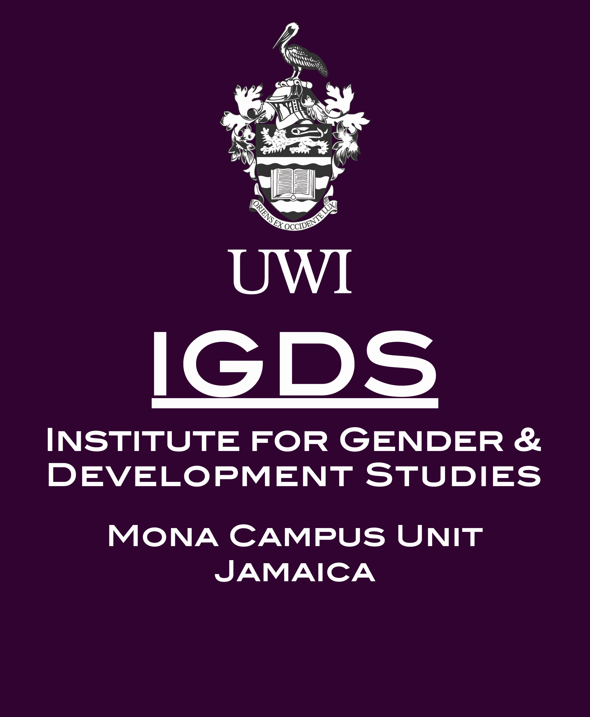

CALL FOR PAPERS

Caribbean Women (Post) Diaspora: African/Caribbean Interconnections

12-13th July 2018
at London South Bank University, London, (UK)

From 12th – 13th July 2018, London South Bank University, the Institute for Gender and Development Studies, Mona UWI, and the LSBU Centre for Research in Digital Storymaking will be hosting an international conference of the AHRC funded African-Caribbean Women’s Post-Diaspora Network http://www.lsbu.ac.uk/schools/arts-and-creative-industries/research/african-caribbean-women-post-diaspora-network.
We invite abstracts (400 words) of papers that address the conference themes. Please submit to goringbl@lsbu.ac.uk.

Keynote Speakers Include

Gina Athena Ulysse (Weslyan University, CT, USA)
Jan Etienne (Birkbeck College, University of London)
Desrie Thomson - George (publisher and visual artist)
Alecia McKenzie with Denise King (novelist with jazz singer)
Diana Evans will be launching her new novel, Ordinary People (Chatto and Windus, 2018).

This interdisciplinary conference is the final event of the AHRC funded African-Caribbean Women’s Post-Diaspora Network. This research network was established to investigate ways of rethinking contemporary concepts of diaspora in African-Caribbean contexts. In seminars and workshops we tested the effectiveness of post-diaspora as a concept that might be used to reimagine new means by which Caribbean women achieve agency through mobility in twenty-first century contexts of globalization, transnationalism and deterritorialization.
Submissions should focus on the specific ways in which gender enables or necessitates mobility, and the unexpected intimacies that emerge from these mobilities. Contributors are asked to examine the political, imaginative, affective and economic affiliations that challenge the proscriptions of the nation-state, and that productively transgress the social and cultural boundaries used to define gender norms and identities.
The conference will address the following key concepts in relation to Caribbean women, (post) diaspora and African-Caribbean interconnections: mobility, agency, diaspora, post-diaspora, migration, transculturality, transnationalism. Presentation topics focusing on Caribbean women and addressing the key concepts can include but are not limited by the following:

Theoretical interrogations of (post) diaspora
Forced migration and trafficking
Diaspora and Development
Narratives of Return
Economic and/or effective consequences of globalisation,
Transnational interconnections
Economic and social mobilities
Imaginative diasporic geographies
Economic models of diaspora
National narratives of diaspora and return
Historical patterns of migration and diaspora
Literary representations of mobility/Literary mobilities
Sonic mobilities
Temporal mobilities
Visual representation and Caribbean women’s mobility and diaspora
Diaspora, (post) diaspora and environmental movement(s)

Panel proposals are welcome. Panels should include a 200 word covering statement in addition to 400 word abstracts.
All abstracts, including panel proposals, to be sent to goringbl@lsbu.ac.uk by 30th April 2018.
Acceptances will be confirmed by 15th May 2018.

CONFERENCE FEE: £50.00 to include all refreshments.
CONFERENCE DINNER (OPTIONAL) £25.00



